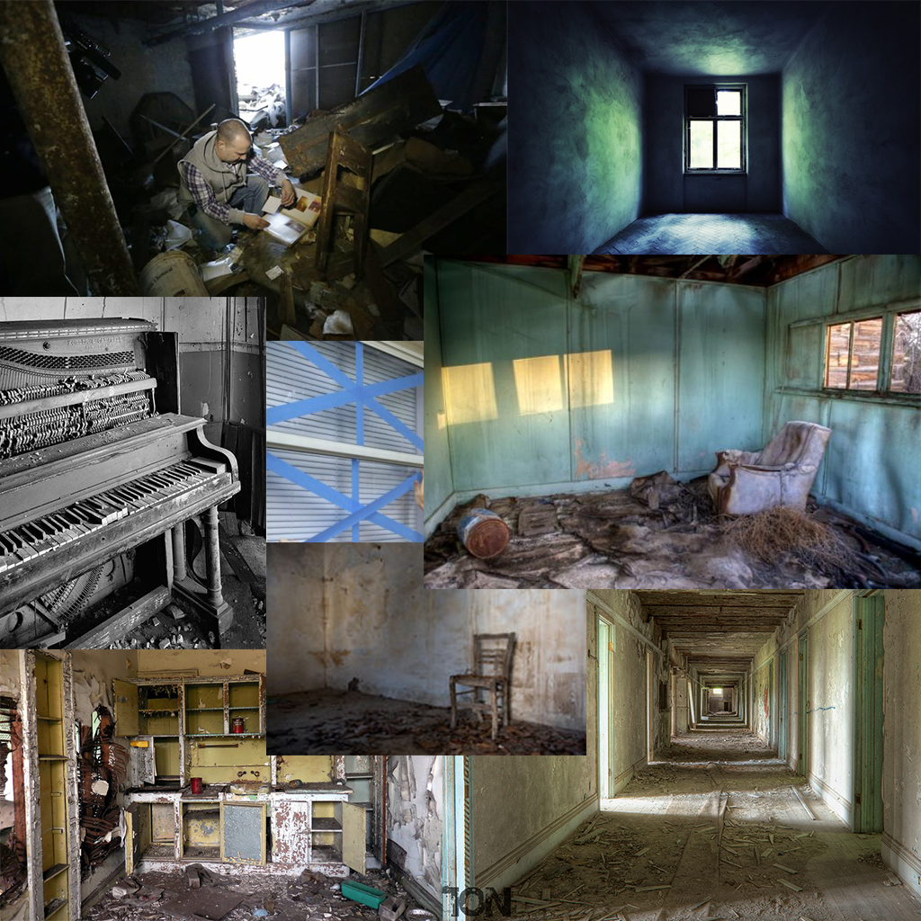

Overgrown areas

In pieces of the store that are in disuse, covered in rubbish, rubble, chips of wood there is some plant life growing through the walls and under the floors, this further shows the state of disrepair and disuse.

The light coming into the building

A dull light fills the room, the lighting from windows will be the main source of light in the building but it will be of very low saturation.

Chipped woods

Left over wood chips on the floor show that the building has at some point been in disrepair and has weathered some sort of damage in the past

Windows Taped

Windows are taped to show where they have shattered, therefore taped windows shows tyhe player that at some point the building needed to be watched for that.

Ruined Interiors

Fixings not complete and empty, other than the books the building is either full of rubbish or are empty

Piano

Grimey, damaged items of ill-repair, showing neglect but not destroyed.

Cluttered Interior

Areas of the building are full of rubbish showing parts of the building that have been left to rot away.